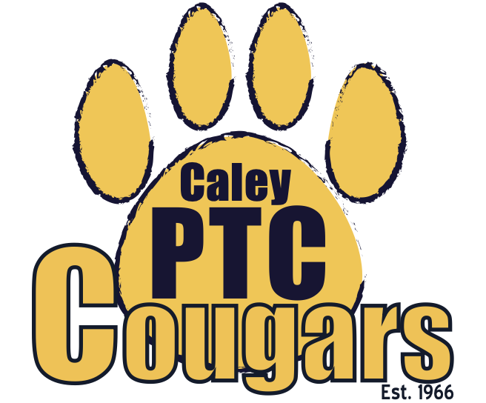
Caley Elementary PTC
Meeting Agenda for Tuesday, October 24, 2023 at 7:00 pm
Cafeteria

Agenda:
- Call to Order
- Welcome and Introductions
  - PTC Board
    - Co-President - Karen Gershanick
    - Co-President - Staci Schetonne
    - Co-Vice President - Desiree Getz
    - Co-Vice President - Ashley Jones
    - Recording Secretary - Kelly McLarnon
    - Corresponding Secretary - Ricki Imhoff
    - Treasurer - Sarah Murray
  - Teacher Reps
    - Wendy Gargan
  - Principal
    - Steve Van Mater
- Officer Reports
  - President’s Report
    - Recent, Current, and Upcoming Events
      - Fall Festival Recap- Need for Security/Staff to monitor inside and playground, signage to “close” property
        - The Fall Festival was a successful, well-attended event! We would like to look into different options next year to make the event even more successful and ensure that it runs smoothly/safely. Ideas for next year included: using the playground area for trunk-or-treat so that all supervision is outback and parking is opened up for the community; aqqincentivize getting more volunteers; changing the time from 5:30-7:30pm.
      - Yearbooks: Hardcover $20.89, Softcover $14.39
        - We will move forward with the soft cover yearbook option. We will need approximately 126 copies of the yearbook for students and staff.
      - Charleston Wrap
        - This fundraiser will run from October 30th-November 13th. It will be all online.
      - Holiday Shop
        - Signup genius will be sent out for volunteers.
        - The holiday shop will begin on Monday, November 27th.
      - Sock Concepts
        - This fundraiser will begin in January. This will be all online.
      - Art to Remember
        - Mrs. Jurina has the art paper and samples. Class lists were sent to ATR. They will be sending ID labels for artwork and finished artwork folders. The goal is to be done by January.
      - Bingo- Have some prizes secured
        - We already purchased great door prizes and grand prizes (i.e. snow cone; popcorn maker; echo dot).
    - Need for google form to submit requests/reimbursements
      - A google doc will be created and provided to staff to formalize requests for funding from PTC.
    - Flyers for events
      - Copies for home need less color to ensure that they can be copied without being too dark and hard to read.
  - Treasurer’s Report
    - Update on incoming and outgoing funds
      - Incoming funds of $1,000 from Frosty Falls fundraiser; adult social; spirit wear sales; small amount of festival payments at the end of the month
      - Outgoing funds of $980 from ice cream social supplies; new cash box for events; prepayment for December Oaks ice skating event

- Teacher Representative’s Report
  - Nurse Dale has ordered and received clothing and undergarments. She is being reimbursed from PTC.
    - Nurse Dale says thank you!
- Principal’s Report
  - Thank you! The digital piano is awesome.
    - We no longer have the frequent expense of tuning the old piano. The saved money will be put towards other instruments. The kids are loving it.
  - The Fall Festival and Scarecrow Contest were great for the kids.
    - Both the fall festival and scarecrow contest were great for the students. Lots of compliments from visitors about the scarecrows!
  - Upper Merion Area Community Cupboard (UMACC)
    - Gravy - Lots of it!
      - 350 gravy donations needed by November 15th.
  - Birthday Parties
    - Food Free Birthday Parties
      - We want to ensure that there are consistent practices amongst all of the elementary buildings. All birthday parties should be food free, no exceptions.
  - Halloween Parade
    - Tuesday, 10/31 at 2:10 pm along the front car line and bus loop.
    - Parade order will likely be 1, 2, K, 3, 4
    - Only parents/guardians who have been identified as homeroom helpers will be allowed in the building.
  - Medicines in School
    - Lip balm and OTC hand lotions are okay to have in their backpacks, especially during the winter season. No medications or cough drops should be in backpacks.
    - Cough drops - If the parent wants them to have cough drops, they need to bring a note and the drops to the health suite. The nurse will keep them in the health suite and give when needed.
- Meeting Adjournment
Next Meeting:
- January 9, 2024 at 7:00 pm

Reach Out to the PTC by email at caleyptc@gmail.com
Visit our website at https://caleyptc.weebly.com/
Visit our spirit wear shop at https://1stplacespiritwear.com/

The Caley Parent/Teacher Co-op (PTC) is a volunteer organization whose purpose is to strengthen, support, and enhance the education of children at Caley Elementary by fostering relationships among the school, parents, and staff. Its goals are to complement the school curriculum with additional opportunities for parents, teachers and students to learn, socialize, communicate and grow together. Through the support of parent volunteers, the PTC provides many fun, educational activities and services that enhance the academic and cultural experiences of our children.

